Flowchart for Menu System

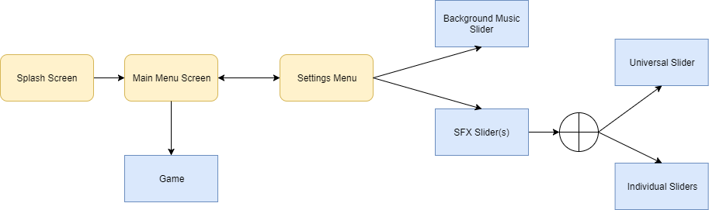

* The Unity splash screen will play before the main title screen loads – may also be able to include a company logo on splash screen
* A single “Tap to start” option takes user straight to main game
* A small settings symbol in the corner of the screen takes the user to a settings menu
  + Settings menu contains a background music slider
  + Also contains a universal slider that allows user to manipulate volume of sound effects **OR** individual sliders that cater to the different sounds in our game, so that users can manipulate different SFX depending on their preferences (as guided by relaxation research)

Pros and Cons of Competitor Games Menu Layouts

**Pros**

* A single action to get into the main game
* Title screen showcases object that you can obtain throughout the game
* All options kept in a single concise “settings menu” 🡪 support information, language settings etc
  + Whether this is in game or on the title screen, this prevents unnecessary clutter and allow the developer to make as much use of screen space to showcase their game as possible
* It is clear which options the user has chosen since they are highlighted in a different colour

**Cons**

* Symbol used to convey the menu is not always clear

Core elements of “Good Menu Design”

* Easily recognised play button, most prominent option that guides the user to the game
* Make sure the user needs as few clicks as possible to get into your game
* Choose appropriate buttons for your type of game e.g. if your game supports the ability to start new games/load current games, have a “new game” and “load game” button on your main menu screen as oppose to a sub menu. This prevents the player from needing to provide unnecessary input at the cost of one extra button on the main screen.
  + In this case settings and possibly a stats option if player wants to show their friend their planet progress without needing to load the main game
  + Don’t clutter the main menu, this will prevent users from getting confused.
  + Symbols can be used to convey the meaning of a button

Mock Up of Main Menu Screen

